R Practice 7 – Graphing with ggplot2

This assignment is just for your own practice and does not need to be submitted. If you have any questions, please feel free to reach out to me, come to office hours, or schedule another a time to meet with me.

Open an R Script in RStudio and complete each of the following. All of your plots should be created in ggplot, not using base R plots.

- Mammal Sleep. In the ggplot2 library, there is a tibble called msleep. You can load this by first loading the ggplot2 library, then the msleep tibble will be available for you.

  - Below is some code for creating a scatter plot of body weight vs brain weight:
ggplot(msleep, aes(x = brainwt, y = bodywt)) +
geom_point()
Copy and paste this code into your R script. Modify this code so that it is a line plot instead of a scatter plot.

  - Modify the code from part (a) so that both the points and the line are plotted. Change the color of the line and change the color of the points to any color you’d like. Note: you can use more than one geom function.
  - Clearly, it is difficult to see all the points on the plot since many are bunched together. We can alleviate this by plotting the on the log scale. Using tidyverse functions, define a new data frame (call it msleep2) with two new variables: one that is the log of brainwt and one that is the log of bodywt. You can just use the log() function to actually take the log of those variables. Then produce a scatter plot with the log of body weight on the y-axis and the log of brain weight on the x-axis.
  - Below is some code to produce a bar plot of the vore variable, which tells us whether the animal is a carnivore, omnivore or herbivore:
ggplot(msleep, aes(x = vore)) +
geom_bar()

However, this bar plot is quite boring looking. Make a bar plot of the conservation variable and make it more colorful with the color and the fill options in the geom_bar() function.

  - The following code will create a histogram for the awake variable, which tells us how long the animal stays awake per day (in hours):
ggplot(msleep, aes(x = awake)) +
geom_histogram(bins = 10)

Modify this code to create a boxplot instead of a histogram. Make the boxplot look better with the color and fill options.

  - The following code will create boxplots of the sleep_time variable split by conservation with the labels changed:
ggplot(msleep, aes(x = conservation, y = sleep_total, fill = conservation)) +
geom_boxplot() +
labs(x = "Conservation Status", y = "Total Sleep Time ", fill = "Conservation ")

Create boxplots of sleep_rem split by the vore variable. Change the labels to be appropriate. Also, explain what the fill option does here. How does this differ from putting the fill option in the geom_boxplot() function?

  - The following code will give density plots of the logbrain weight in the msleep2 data frame you created in part (c) split by conservation. If you called your variable something different than logbrain in part (c), you will have to adjust that here. This code also adjusts the labels, adds a title, and changes the font size.
ggplot(msleep2, aes(x = logbrain, fill = conservation)) +
geom_density(alpha = 0.5) +
labs(x = "Log(Brain Weight)", y = "Density") +
ggtitle("Density Plots of Log(Brain Weight)") +
theme(axis.title = element_text(size = 14))

Adjust this code to make density plots for logbody (that you also created in part (c)) split by vore. Adjust the labs() and ggtitle() functions to make them appropriate for this situation. Also, change the size of the axis labels to be 16.

- College Distance. On Canvas is the data set CollegeDistance.csv that was collected in the 1980s on high school students. This data set contains the following variables:
gender: factor indicating gender.
ethnicity: factor indicating ethnicity (African-American, Hispanic or other).
score: base year composite test score. These are achievement tests given to high school
seniors in the sample.
fcollege: factor. Is the father a college graduate?
mcollege: factor. Is the mother a college graduate?
home: factor. Does the family own their home?
urban: factor. Is the school in an urban area?
unemp: county unemployment rate in 1980.
wage: state hourly wage in manufacturing in 1980.
distance: distance from 4-year college (in 10 miles).
tuition: average state 4-year college tuition (in 1000 USD).
education: number of years of education.
income: factor. Is the family income above USD 25,000 per year?
region: factor indicating region (West or other).
- Read this data set into R. Use a tidyverse function to read it in as a tibble rather than read.csv or read.table.
- Create a bar plot of the gender variable. Give it a title and change the y axis label to “Frequency”. Feel free to make the bars look nicer as well!
- We are not going to do the pie chart on this assignment. Pie charts are inferior, so ggplot does not even have a built-in way to create them! Instead, make a stacked bar chart for ethnicity split by income (one bar for each income) so that each bar has a height of 1. Adjust the labels so that they are “African American”, “Hispanic”, and “Other”. You can do this with the labels option in the scale_fill_manual function. Then change the color so the African American part is blue, the Hispanic part is green, and the Other part is orange. Give this plot a title as well.
- Create a scatter plot with tuition on the y-axis and unemp on the x-axis. Change the x and y labels to be “Unemployment Rate” and “Average 4-Year College Tuition (in thousands)”. Change the plot so that the points are filled-in dark blue dots. Then change the size of the labels to be 14. To change the size of the labels, you can put axis.title=element_text(size=14) in the theme function. The default size is 11. Finally, put a title and make it size 14 and bold. To change the size and font type of the title, you can put plot.title = element_text(size=14, face = "bold") in the theme function.
- Create a histogram of the distance variable. Change the x-axis label so the units of distance are shown and add a title. Also, change the color from gray to light blue and put borders around the histogram bars. Finally, change the theme to be the dark theme using theme_dark().
- Create side-by-side boxplots for the score variable split by income. Change the x-axis and y-axis labels and give the plot a title. Change the color of the boxplots to one of your choice.
- Create a bar plot of gender with bars split by ethnicity. Be sure to include the
position = "dodge" to get ggplot to put the bars side by side.

- Nile River Flow. The file nile.csv is on Canvas and contains information about the annual flow of the Nile River at Aswan measured in ${10}^{8}$ cubic meters from 1871 to 1970.
  - Read the data set into R using a tidyverse function.
  - Consider the plot below. Try to recreate it as closely as you can. You can add more ticks on the y axis by using scale_y_continuous(breaks = vector of breaks) in the plot.
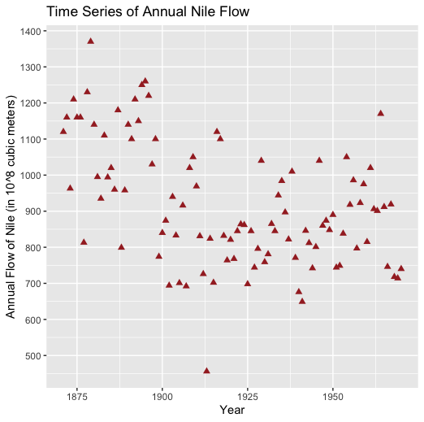

- Airlines. The file airlines.csv can be found on Canvas. This data set contains information about 6 airlines from 6 years between 1970 to 1984. This includes the airline, the year, the cost (in $1,000), the output index number (in revenue passenger miles), the fuel price, and the average load factor of the fleet.
  - Read the data file into R using a tidyverse function. Change the airline variable from numeric to a factor using a pipe and a tidyverse function.
  - Create a plot that looks like the one on the below. Note, the range on the y-axis is from 0 to 5,000,000. You can change the color using scale_color_manual(values = c(put colors here)). The line type can be changed by putting geom_line(aes(linetype = airline)). Then you can put points as well as the lines by adding geom_point().
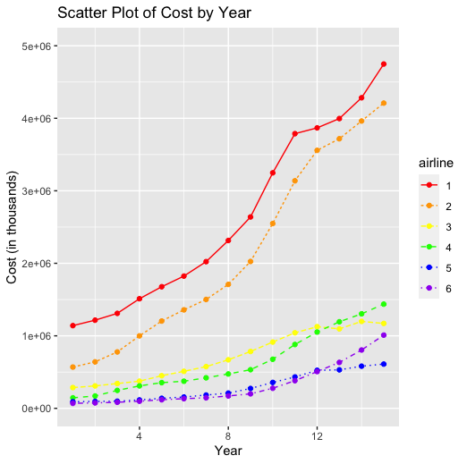
  - Now, instead of plotting all six airlines on the same plot, use facet_grid to graph six plots (one for each airline) side-by-side. Be sure to put labeler = label_both in the facet_grid function so it is more readable.

